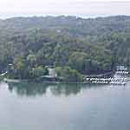 | Privateer Yacht Club  invites you to Beautiful Chattanooga, Tennessee for the  2008 USODA  Southeastern Optimist Championships  And Green Fleet Fun Regattas  October 4 - 5, 2008
Venue | Privateer Yacht Club (PYC), 4713 Privateer Road, Hixson (Chattanooga), TN 37343. 423-877-9411
Rules | The races will be governed by the rules as defined in The Racing Rules of Sailing. NOR provided at a Later Date
Entries and  Eligibility | This regatta is open to all current members in good standing of the USODA. The Regatta is a qualifier for the USODA Team trials of 2009. The top 25% qualify. Participant must have been born prior December 31st in the year they turn 15. There will be a CHAMPIONSHIP AND GREEN FLEET RACE COURSE.  Now, what's green fleet? Green fleet is a special fleet for beginners. Green fleeter’s can be any age up to 15. They will sail their own short courses and coaching is allowed on the bottom half of the fleet during the races. This is not serious racing. Participation awards will be presented to all green fleet sailors.
Registration | Boat registration is: $80 for those who pre-register prior to 9/1/08 (You will also receive a FREE T-SHIRT), $100 prior to midnight 10/1/08 this is the end of pre-registration, No T Shirt. $120 at the regatta on 10/3 & 4. This includes all fees, Breakfast and Lunch each day.  Additional T-Shirts maybe ordered in advance. Below is the design to be used on the back.   REGISTER BY 9/1/08 * GET A FREE T SHIRT  - Registration forms will be available at www.privateeryachtclub.org  - Charter boats are available at www.optistuff.com or call 800 784 6478  NOTE: All times are tentative and will be published in the final NOR.
Schedule  of  Events | Awards Ceremony  NOTE: All times are tentative
  Date | Time | Event
  Friday, OCT 3 | 1800 | Registration.
  Date | Time | Event
  Saturday, OCT 4 | 07:30 | Continental Breakfast
   | 07:30 – 9:00 | Registration
   | 9:30 | Skippers Meeting
   | 10:00 | Harbor Start Championship Fleet
  Racing to follow
  Lunch to be served on the water
   | TBA | Dinner
   |  | All meals will be available to adults for an extra charge
  Date | Time | Event
  Sunday, OCT 5 | 7:00 | Continental Breakfast
   | 9:00 | Harbor Start Racing to Follow
   | 14:00 | No race to be started after this time
Questions/Inquiries | ALISA@Optistuff.com, Steve@Optistuff.com 800 784 6478  Privateer YC Web site (www.privateeryachtclub.org)
Lodging | - Camping on the Idyllic Beautiful Tennessee River 75 feet from the clubhouse - Showers in the club.  - Motels near intersection of Highway 153 and Hamill Road - about 2 miles from clubhouse  - Hampton Inn - 1920 Hamill Road, Hixson, TN 423-877-3100  - Comfort Inn - 4833 Hixson Pike, Hixson, TN 423-877-8388  - Holiday Inn Hotel and Suites - 4820 Hixson Pike, Hixson TN 423-877-6464  - Country Inn & Suites by Carlson – 5105 Hi-way 153 North, Hixson TN 423-308-2333
General | 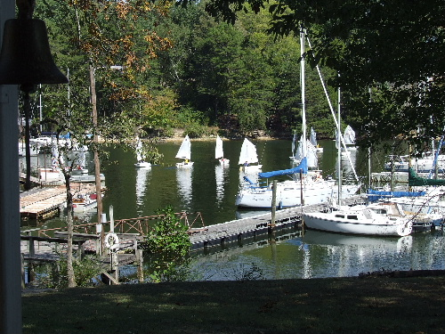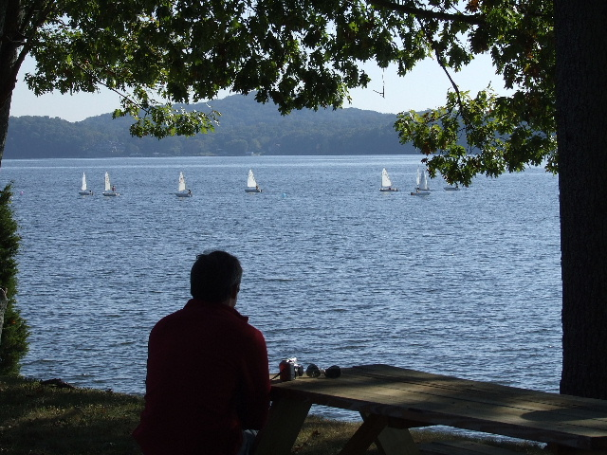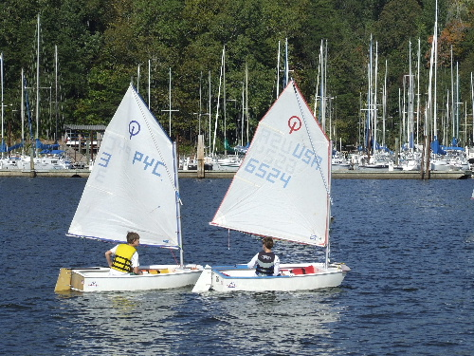  October is the perfect time to be sailing in Tennessee, the wind is up, temperatures are in the 70’s and our fall foliage is beginning to appear.  Racing Takes Place Directly in front of the clubhouse. No long sail to the starting line. Come join us for great sailing and a true laid back Southern Experience. Privateer Yacht Club is a racing club and as such does not have a full time restaurant, bar or snack bar.  The City of Chattanooga is a tourist destination with many child friendly attractions. See www.chattanoogafun.com for details.  With in easy walking distance downtown you will find: The Tennessee Aquarium, Museum Arts District, IMAX Theater, spectacular River Front Park and Walk, Children’s Discovery Museum, Chattanooga Carousel with animals carved at the city’s carving school ($.50 per ride), pedestrian bridge over the Tennessee River joining the North and South Downtown Tourist areas and the Chattanooga Lookouts minor league baseball stadium. On the University of TN campus a few blocks from the downtown area is the Challenger Space Museum with full size working mock up of the Space Shuttle and NASA control room (free admittance). South of the city is Chickamauga Battle Field. 5200 acres make this the largest battlefield with over 250 cannons, 300 monuments, museum, and holograph sound and light show depicting the Civil war and the 48-hour battle that took place here. Over 26000 troops were wounded or killed in a 2-day period. It was a major turning point of the Civil War. Chattanooga has some of the best hiking trails, climbing, white water rafting / kayaking and hang gliding in the United States. With in easy drive from downtown on Lookout Mountain are Ruby Falls, Rock City and one of the oldest inclines in the US. All this and much more will make you want to add an extra day to your trip.  Tours of McLaughlin Boat Works, the only Optimist facility American  Steve’s Gelcoat repair seminar for the parents
Directions | (Click on map for details)  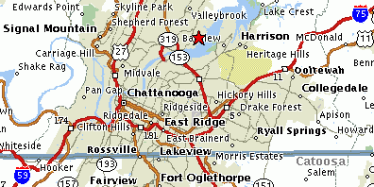

Directions to the Privateer Yacht Club

From I-75 South: Take I-24 to I-75 North and then follow the directions below.

From I-75 North Or South: Exit I-75 on to Highway 153 North. Follow 153 north approximately 6.8 miles crossing the Chickamauga Dam. Just as you leave dam take the Lake Resort Drive exit. Go fully around the traffic circle (Round About) and turn onto Lake Resort Drive. Travel approximately 1.5 miles to the intersection with Gann Store Road. There will be a triangle of grass in the intersection on your right. Turn right onto Gann Store Road. Follow this past Gold Point Marina, about 1.1 miles. Keep going about 5 more blocks until the road makes a 90-degree right and then an immediate 90-degree left at the top of a slight hill. Do not take the 90-degree left but go straight ahead onto Privateer Road. At the bottom of the road is a Cul D Sac. Going out the bottom is the Yacht Club sign and entrance gate.

